**Pharmacy app log in**

**Healthera**

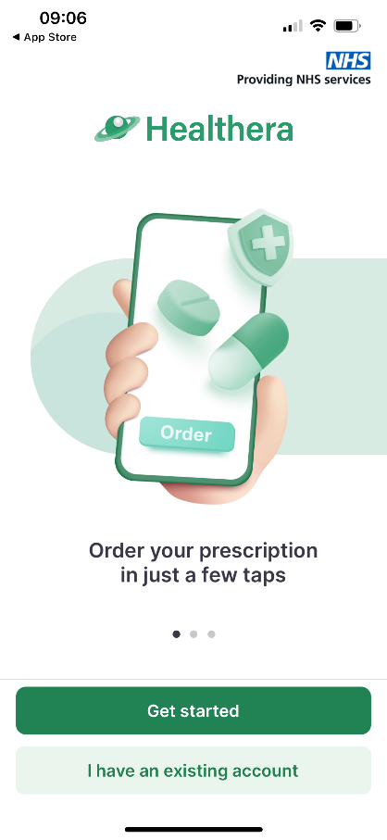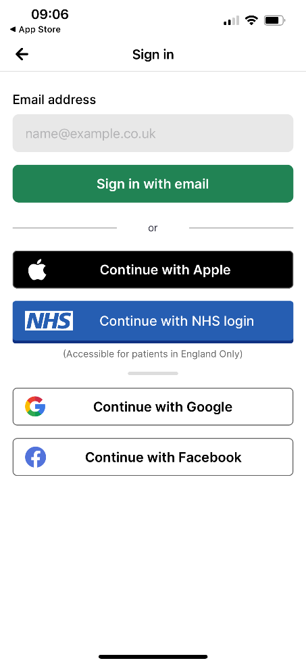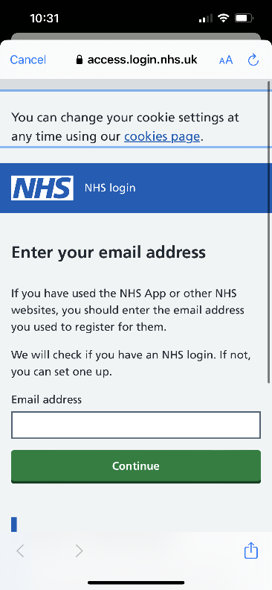

**Open Healthera pharmacy app and click on 'I have an existing account'**

**To log in, click on 'NHS – Continue with NHS login'**

**If you do not have a NHS login, this can be created on the next page**

**DO NOT sign in with email**

**Type in your email address and click on continue**

**Log in with your NHS app details or create a NHS log in**